WEB UI – TO MAKE USER TO INTERACT WITH THE SOFTWARE

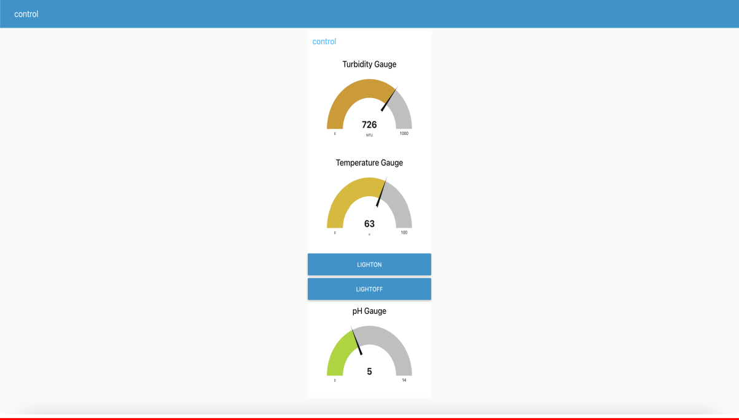

FIGURE-1: WEB UI CREATED USING NODE RED DASHBOARD

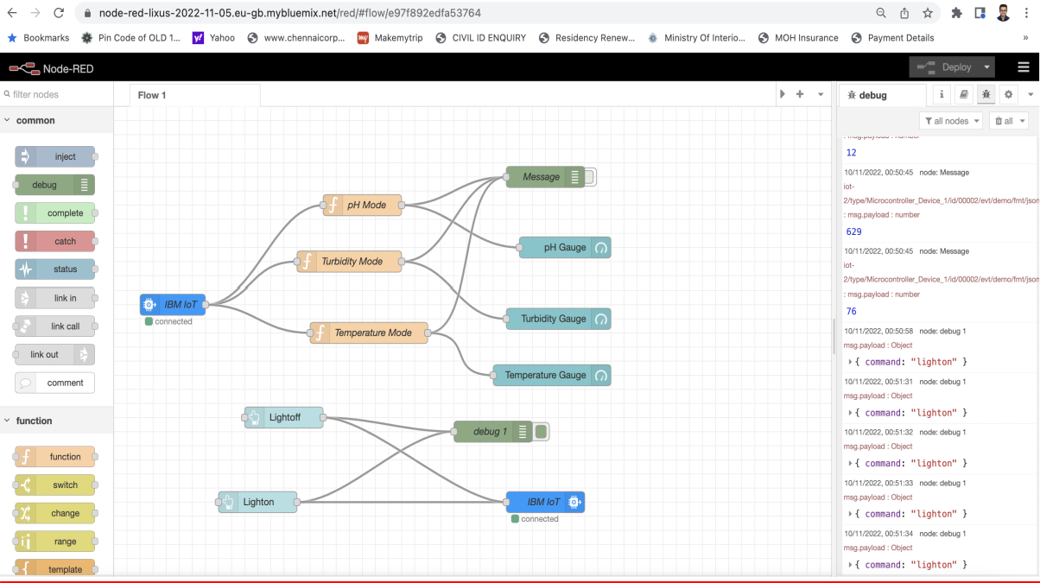

FIGURE2: WHEN THE LIGHTON BUTTON IS PRESSED

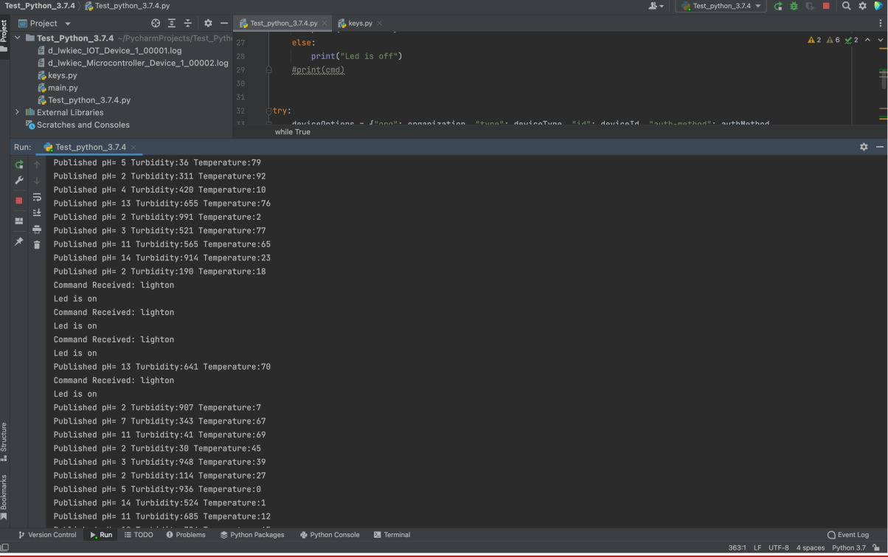

FIGURE3: PYCHARM SOFTWARE OUTPUT CONSOLE WHEN LIGHT ON BUTTON ON WEB UI IS PRESSED

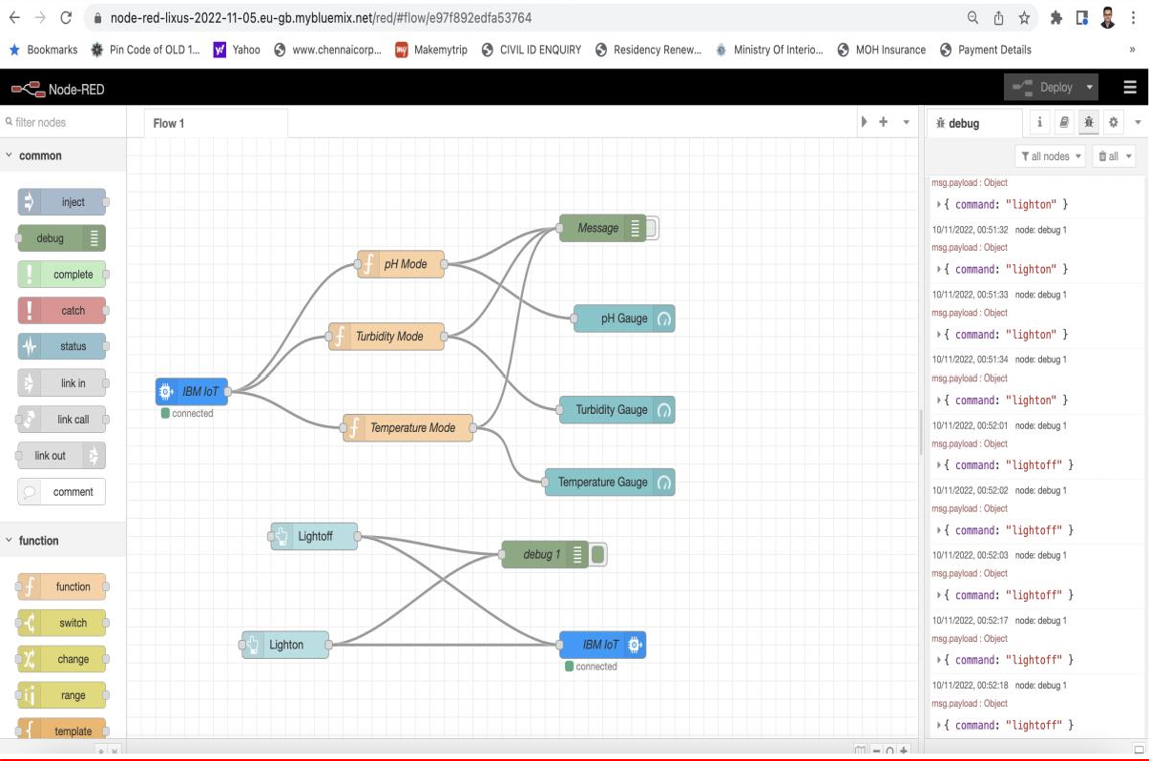

FIGURE4: WHEN LIGHTOFF BUTTON IS PRESSED ON THE WEB UI

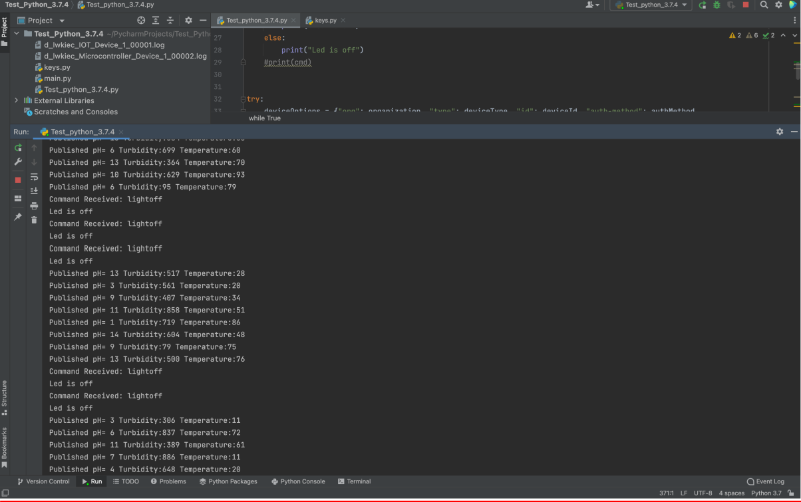

FIGURE5: PYCHARM SOFTWARE OUTPUT CONSOLE WHEN LIGHT OFF BUTTON ON WEB UI IS PRESSED